Shot | Shot length  Min:sec:frame | Shot Type | Dialogue (beginning and end of lines) | Action | First Frame | Last Frame
1 | 00:00:00 - 00:04:15 | Med-long shot. Static. | None. | Allen looks towards Bateman (frame left, character right) | 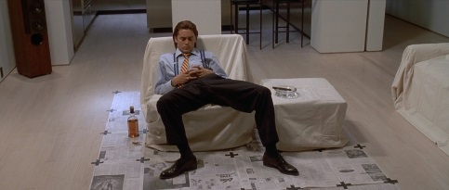 | 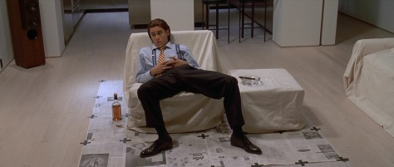
2 | 00:04:16 – 00:07:15 | Close up, pan (R-->L) | “you like Huey Lewis and the News?” | Bateman picks up the album “fore” holds it up for Allen to see. | 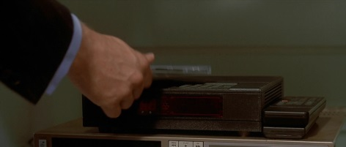 | 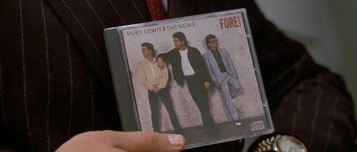
3 | 00:07:16 – 00:09:21 | Med-close. Static. | “They’re ok” | Allen answers gesturing slightly, | 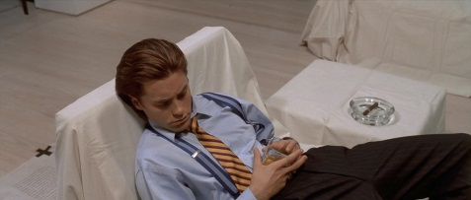 | 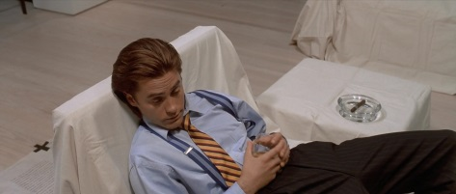
4 | 00:09:22 – 00:21:20 | Medium. Pan (R-->L) | “Their early work… commercially and artistically” | Bateman puts “fore” back down, walks frame left, character right. Stops near the centre of the room. | 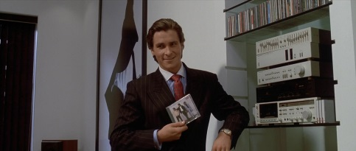 | 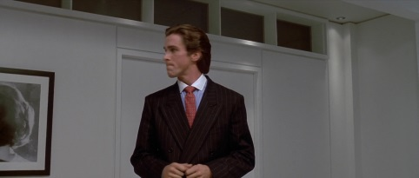
5 | 00:21:21 – 00:25:00 | Wide. Static. | None. | Bateman walks out towards the bathroom, Allen reaches for the bottle. | 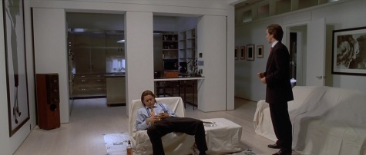 | 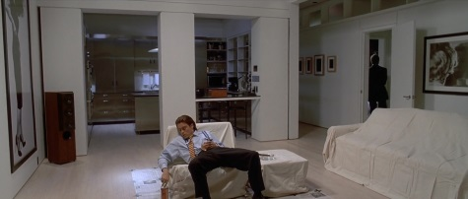
6 | 00:25:01 – 00:33:20 | Med-close. Pan (up). | “The whole album… a big boost” | Bateman walks into the bathroom, picks up the rain coat, walks to the mirror puts it on, while staring at himself. | 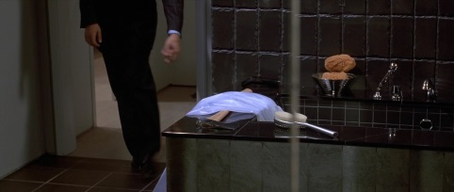 | 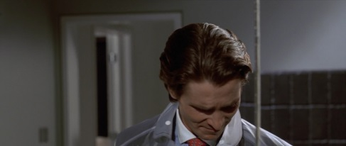
7 | 00:33:21 – 00:36:21 | Close. Mostly static (slight pan up, change in focus) | None. | Bateman picks up some loose pills of the table. Then picks up the glass. | 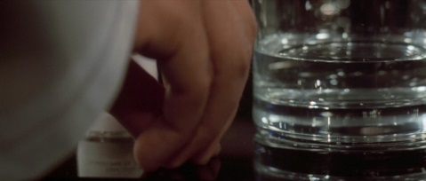 | 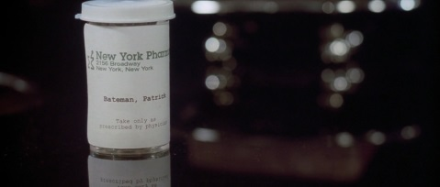
8 | 00:36:22 – 00:43:00 | Med-close (continuation from end of shot 6) | None. | Bateman drinks, and then sets the glass down, still staring at himself. Walks towards the door bending down slightly to pick up the axe and then beginning to moonwalk out of the door. | 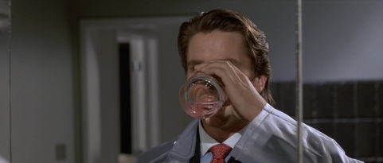 | 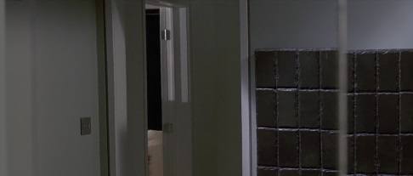
9 | 00:43:01 – 00:47:08 | Wide. Slight pan (RL) | “he’s been compared… has a far more bitter…” | Bateman moonwalks out of the bathroom (towards frame left) | 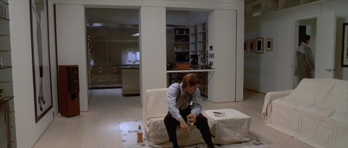 | 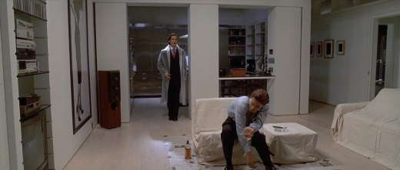
10 | 00:47:09 – 00:50:06 | Close up. Static | “…cynical edge sense of humour” | Bateman leans the axe against the wall | 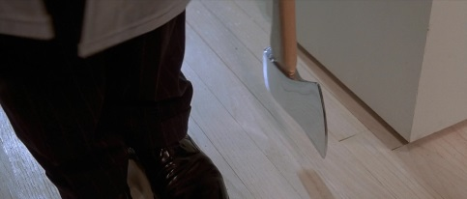 | 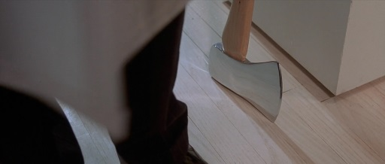
11 | 00:50:07 – 00:52:06 | Wide (continuation from end of shot 9) | “Hey albestram, yes Allen?” | Bateman begins buttoning up the raincoat. Allen drunkenly points at Bateman. | 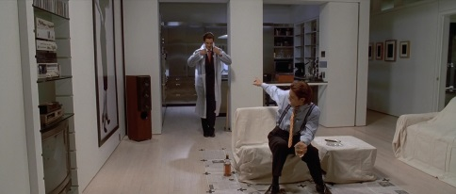 | 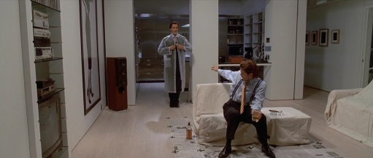
12 | 00:52:07 – 01:00:03 | Medium. Static. | “why are there copies… a little chow or something” | Allen gestures around (regarding the paper on the ground) |  | 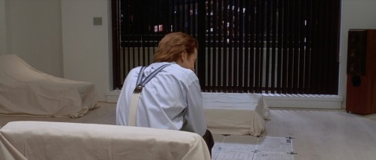
13 | 01:00:04 – 01:01:13 | Close up. Static. | “No Allen.” | Slight shake of the head. | 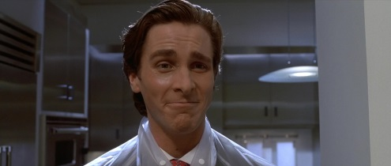 | 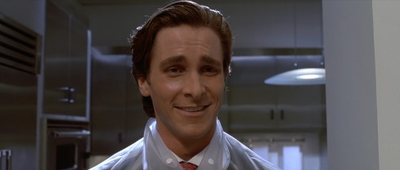
14 | 01:01:14 – 01:05:10 | Med-close. Static | “is that a raincoat? Yes it is” | Bateman finishes buttoning the raincoat and walks out of frame left towards the cd player. | 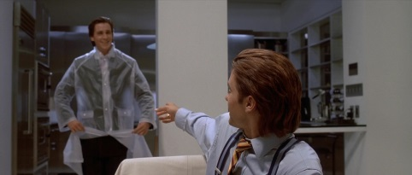 | 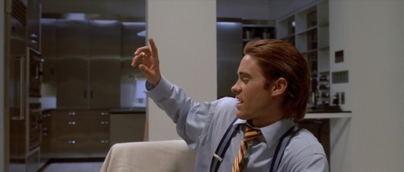
15 | 01:05:11 – 01:10:01 | Med. Static. | “In ’87… their most accomplished album” | Bateman walks into frame right, presses play on the machine, the song starts playing. Bateman points at the player as he describes the song | 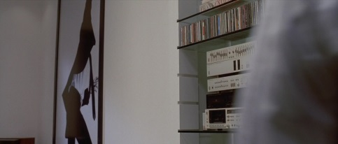 | 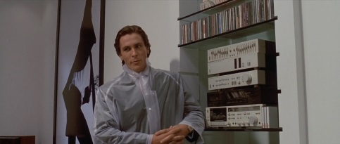
16 | 01:10:02 – 01:16:16 | Wide. Pan (R L) | “I think their… don’t listen to the lyrics” | Bateman walks/dances towards camera and then out of frame left, | 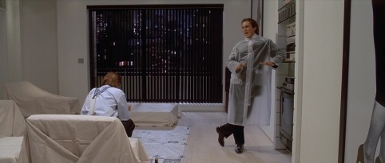 | 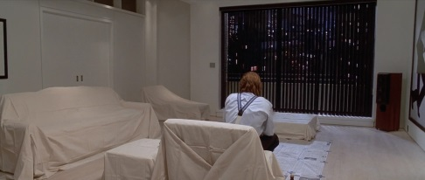
17 | 01:16:17 – 01:26:11 | Med. Slight pan up. | “But they should…. Hey Paul!” | Exaggerated point on “but they should”. Raises the axe on “because it’s not”. Exaggerated gesturing with both hands on “and the importance”. Lowers the axe on “hey Paul” | 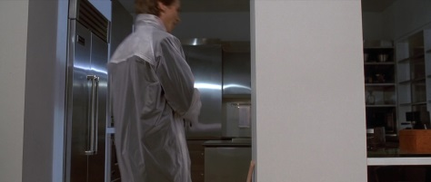 | 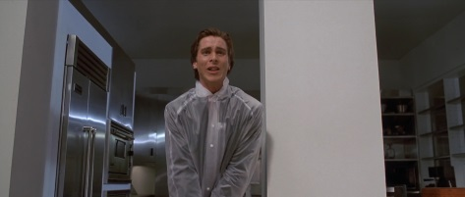
18 | 01:26:12 – 01:27:22 | Close up. Static. | None. | Allen turns around and reacts in horror. | 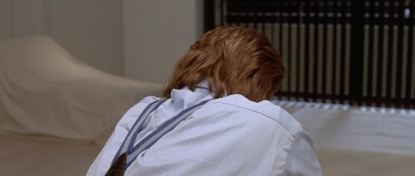 | 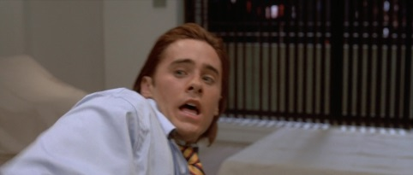
19 | 01:27:23 – 01:30:22 | Med-close. Static. | None. | The axe is raised when it cuts back, Bateman brings it down while screaming. Thud. Blood splatters the right side of his face. Bateman moves out of frame left. | 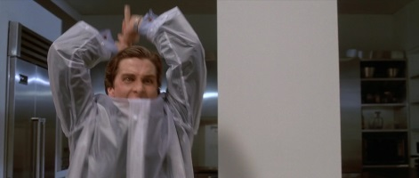 | 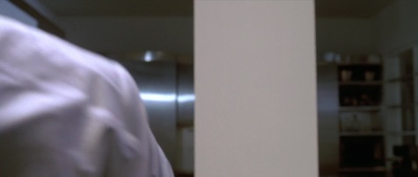
20 | 01:30:23 – 01:31:19 | Close up. Static. | None. | Allen body hits the ground. Blood spills out over the newspaper. | 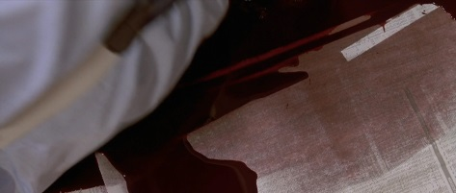 | 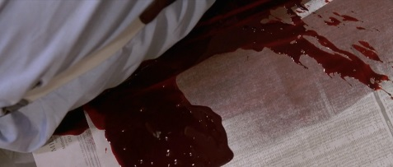
21 | 01:31:20 – 02:16:13 | Close up. Pan (LR) | “Try getting a reservation… you fucking bastard” | Bateman screams at Allen, hits him with the axe 6 times, then drops the axe, looks around catching his breath. Takes off the raincoat. Steps over Allen’s body. Walks towards the couch, sits down. Fixes the hair on the right (bloodied) side of his face. Puts a cigar in his mouth. Reaches into his pocket for a lighter. | 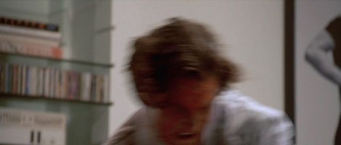 | 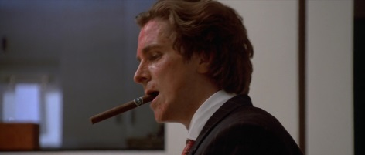
22 | 02:16:14 – 02:27:04 | Wide. Static. | None. | Lights the cigar, closes the lighter, puts it back in his pocket, crosses his leg and sits back smoking the cigar. | 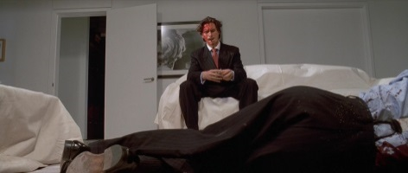 | 