Thank you for applying for our adaptation of the American Psycho Axe Murder Scene. As you know, the scene consists of two roles, Patrick Bateman and Paul Allen. It occurs right after Patrick Bateman deliberately spends the night getting Paul Allen totally hammered, bringing him back to his apartment thereafter with the intention of chopping him to bits.

Date: 10/10/2014

Time: 1-3pm

Location: UNSW Arc Music Room, UNSW Campus, Kensington, Sydney, NSW
HERE

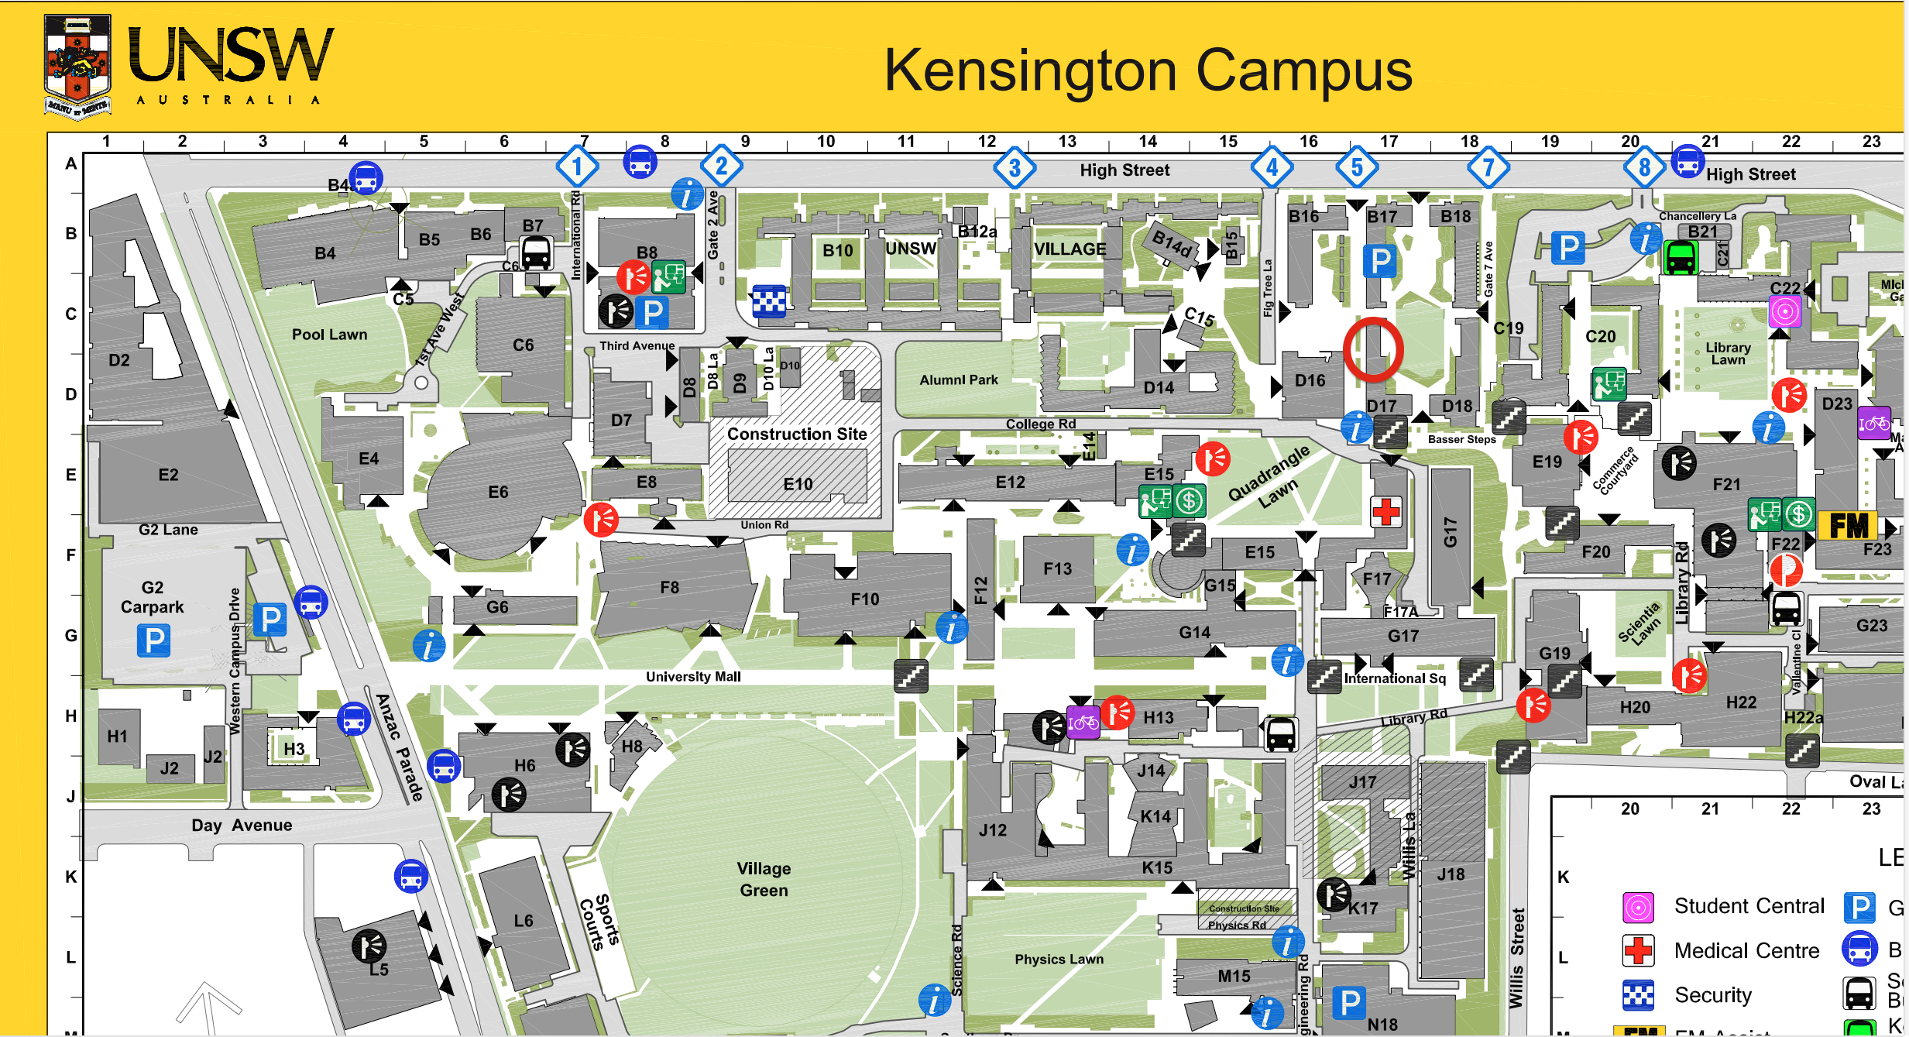

*On the day itself, should you have difficulty in locating us on campus, please do not hesitate to call our Producer and he will come fetch you.

Chris Ho

0415807969

Audition Preparation

Patrick Bateman
-Narcissistic, robotic, has learned to imitate emotions since he himself has none (aside from greed, vanity and anger), has managed to achieve a friendliness that is empty behind the smile
-Tips: https://www.youtube.com/watch?v=8lLl95A1-jI (Christian Bale interview)

Objective: Try to put yourself in Patrick’s headspace, what do you want to achieve? What is the point of all this? Revenge? Entertainment?

Intention: What are you thinking of during this scene? Knowing what you are about to do, how does that make you feel? A predator circling an unsuspecting prey? A spring coiled under tension, ready to lash out at the opportune moment? Are you nervous? Excited?

Backstory: Patrick despises Paul because in some ways Patrick feels that Paul is better than him. In their superficial world, the better man is the one that is more financially successful, the one with the better apartment, the one with the better haircut, the one with the better suit, the one who can get a reservation at the fanciest restaurant in town (i.e Dorsia). Paul has been boasting to everyone that he can easily get reservations at Dorsia anytime he wants prior to this scene whereas Patrick has tried and failed miserably. This reason, among others, chiefly drives his murderous intent. From one alpha male to the next, Patrick wants to remove the competition and put himself back on top. Patrick identifies himself by his material possessions and the image that he projects to the world. Paul has threatened this identity by having one that seems superior. Patrick needs to destroy him utterly in order to feel good about himself again.

Audition piece:

Page 3-5 of script, from when Patrick re-enters the room from the toilet till he drops the axe and sits down.

Raincoat and a stick (to simulate the axe) will be provided.

Paul Allen
-Egotistical, proud, thinks that everyone likes him, snobbish, asshole who is completely oblivious that he is an asshole
-Tips: https://www.youtube.com/watch?v=_M0PhC21C7k (Jared Leto interview)

Objective: You think you are with a friend. You are completely hammered but you feel quite safe. You think you are better than Patrick and are doing him a favor tonight by hanging out with him. You feel that he owes you, that this night feels sort of like charity on your part.

Intention: Are you checking out his apartment? Maybe you think yours is much better, judging everything you see. You are pretty wasted. Maybe you are simply trying to get your shit together in order to form proper words. It takes everything in your power just to hold your glass straight and sit without falling off the chair.

Audition piece:

Pages 3-4 of script, from when Patrick re-enters the room from the toilet till Patrick walks over to the CD player.

Chair and whiskey glass will be provided.

Please come in prepared to audition for one or both of the available roles.

We look forward to seeing you at the auditions, all the best!

Cheers!

